**NORTHERN CARIBBEAN UNIVERSITY**

**College of Natural & Applied Sciences**

**Department of Computer & Information Sciences Spring 2021**



**Internet Authoring Final Project**

**Lecturer:** Mr. R. Thompson

**Course**: Internet Authoring

**Group Members:**

Nakarda Richards

Roshaun Hodgson

Kevardo Brown

Pedro Calzado

Online Gym Management System

Physical fitness is to the human body what fine tuning is to an engine. Regular exercise and physical activity promote strong muscles and bones. It improves respiratory, cardiovascular health, and overall health. Staying active can also help you maintain a healthy weight, reduce your risk for type 2 diabetes, heart disease, and reduce your risk for some cancers. Fitness can be described as a condition that helps us look, feel and do our best. Many people join gym to remain physically fit.

**Problem Definition:**

Physical health plays a critical role in the lives of humans today as it reduces the risk of the following: heart attack, obesity, high blood pressure and type 2 diabetes and osteoporosis. Gym facilitators must provide an easier and more efficient way for individuals to achieve better physical health during and after the pandemic as gym members are filing complaints that if they couldn’t buy equipment and train from home, and individuals who are interested in joining gyms are requesting for gym applications to be offered online in order to: reduce gatherings due to COVID-19, reduce transportation cost as individuals sometime have to travel from a distance to get the application and also participate in the fitness activities. When interviews were carried out virtually 85% of the individuals that were interviewed stated that the problems that they were having with the gym system were:

* Traveling too far to improve their physical health which can be costly.
* Gathering to get applications place their health at risk as they had to line up and gather to collect membership form or apply for membership and they are not aware who may have COVID-19.

**Solution Definition:**

The solution to this problem is to create an Online Management System for general public, gym members, gym administrators and trainers which will be used to:

Manage Members: The system will be used to register individuals as their will be a registration form available on the system which will allow individuals to complete registration from any location. The system should be able to provide members with the different exercises that will be carried out base on their different fitness levels. This website will help people to get registered and choose the trainer. In this system there are three entity namely Admin, Member and Trainer. Admin can login, Add new members. Admin can also delete the members who left the gym. Admin will add new trainer, Update the information of trainer, and delete the trainer. Admin can also modify members data and trainer’s shift. Member can login using credentials and transfer money online. Trainer can login and mark the attendance of the members.

Target:

* General public
* Gym members
* Gym trainers

**The 3 Main Entities:**

**1. Admin:**

* **Login:** Admin can login using credentials.
* **Add member:** Admin can add new member.
* **Delete member:** Admin can delete unwanted members.
* **Add Trainer:** New trainer can be added.
* **Delete trainer:** Unwanted trainers can be deleted.
* **Modify Member Data:** Admin will modify data of members.
* **Modify Trainers Shift:** Admin will modify trainers shift.

**2. Members:**

* **Sign up:** New members can sign up.
* **Login: Members can login using credentials.**
* Chose a trainer and select from the available time slot.

**3. Trainers:**

* **Login:** Trainer can login using credentials.

Can view members assigned.

Minimum Hardware Requirement:

* i3 Processor Based Computer or higher
* Memory: 4 GB Ram
* Hard Drive: 100GB

Software Requirement:

* Windows 7 or higher 64bit
* Visual Studio Code or any other IDE suitable
* MySQL
* MySQL Workbench
* Xampp
* Google Chrome Browser

**Solution Architecture:**

|  |  |
| --- | --- |
| Use Case | Description |
| Add new member | Administrators can add new members once a registration is done. |
| Update trainer | Administrators can update trainer’s information which can be personal or gym related information. |
| Delete trainer | Administrators can delete trainers if the trainer decides to resign. |
| Delete member | Administrators can delete member if member decides to leave or payment is not being made to account. |
| Update member | Administrators can update members information which may include upgrade in gym program. |
| Register for gym | Members of the public may visit site and register for a gym |
| Choose time slot | Members can choose time slot that best suites and be added if there is not enough member using that time slot already. |
| Select trainer | Members can select any trainer once they have vacancy to train more members. |
| Mark member attendance | A trainer can mark member attendance that is a part of his/her program. |
| Describe performance | A trainer can describe a member’s performance to determine if he/she is fit to take a higher level of experience |

**Use Case Diagram:**

General Public and Member Interaction with Application:

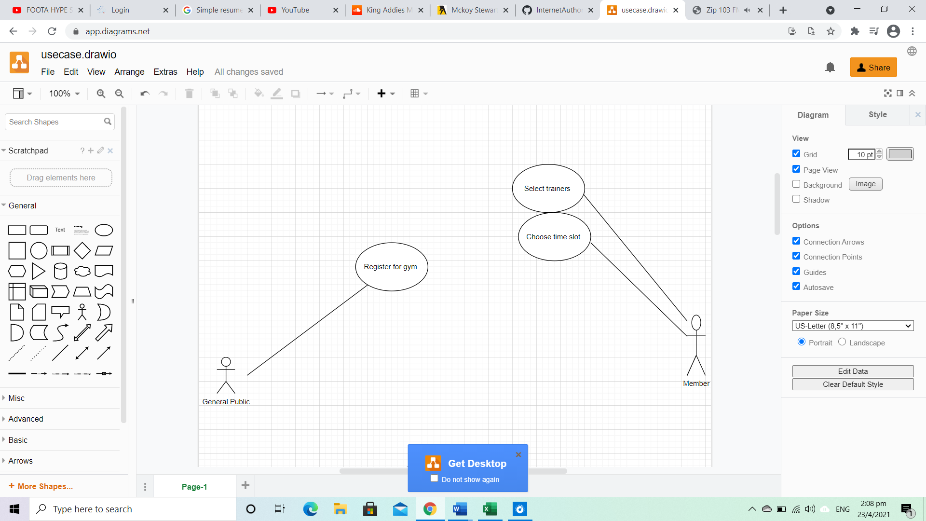

Trainer and Administrator Interaction with Application:

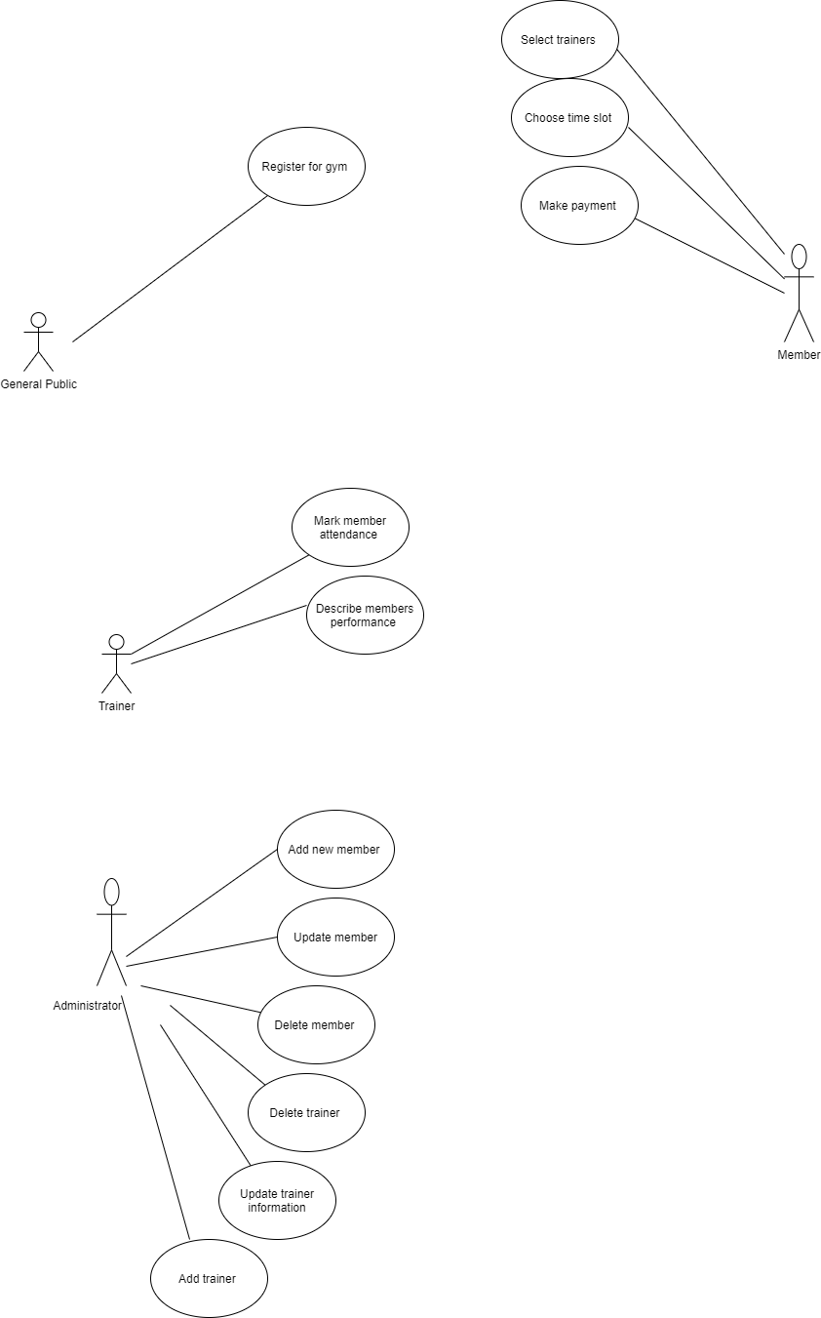

**Activity Diagram:**

Admin adding member to system:



Admin updating member record:



Admin deleting member:



Admin adding trainer:



Admin updating trainer record:



Admin deleting trainer record:



Trainer Marking Register:

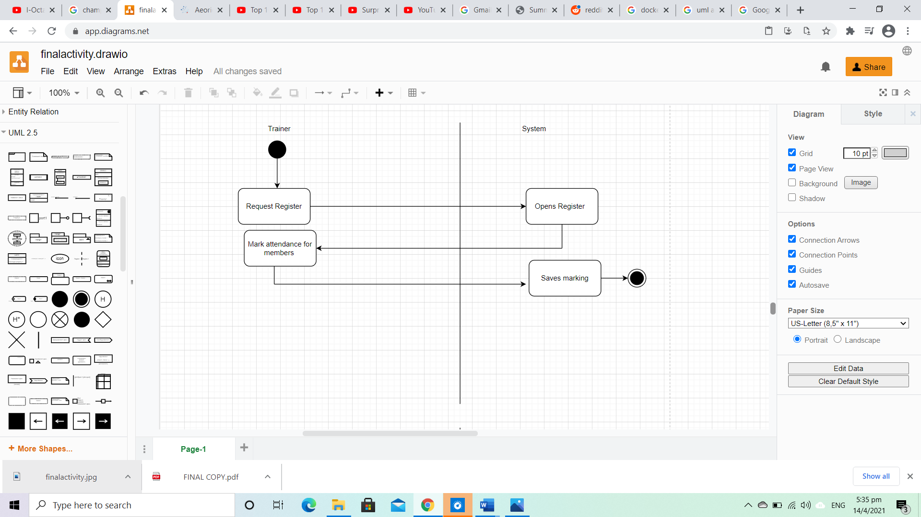

Trainer Describing Member Performance:

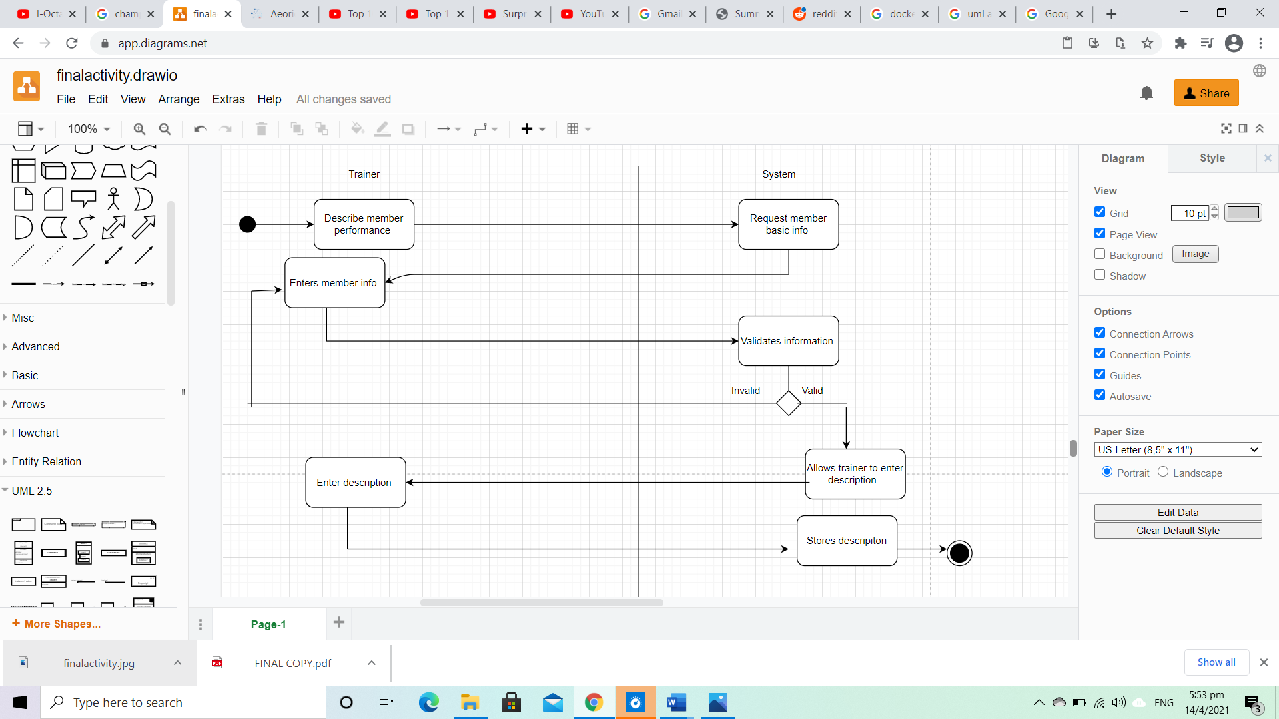

Member viewing trainers:

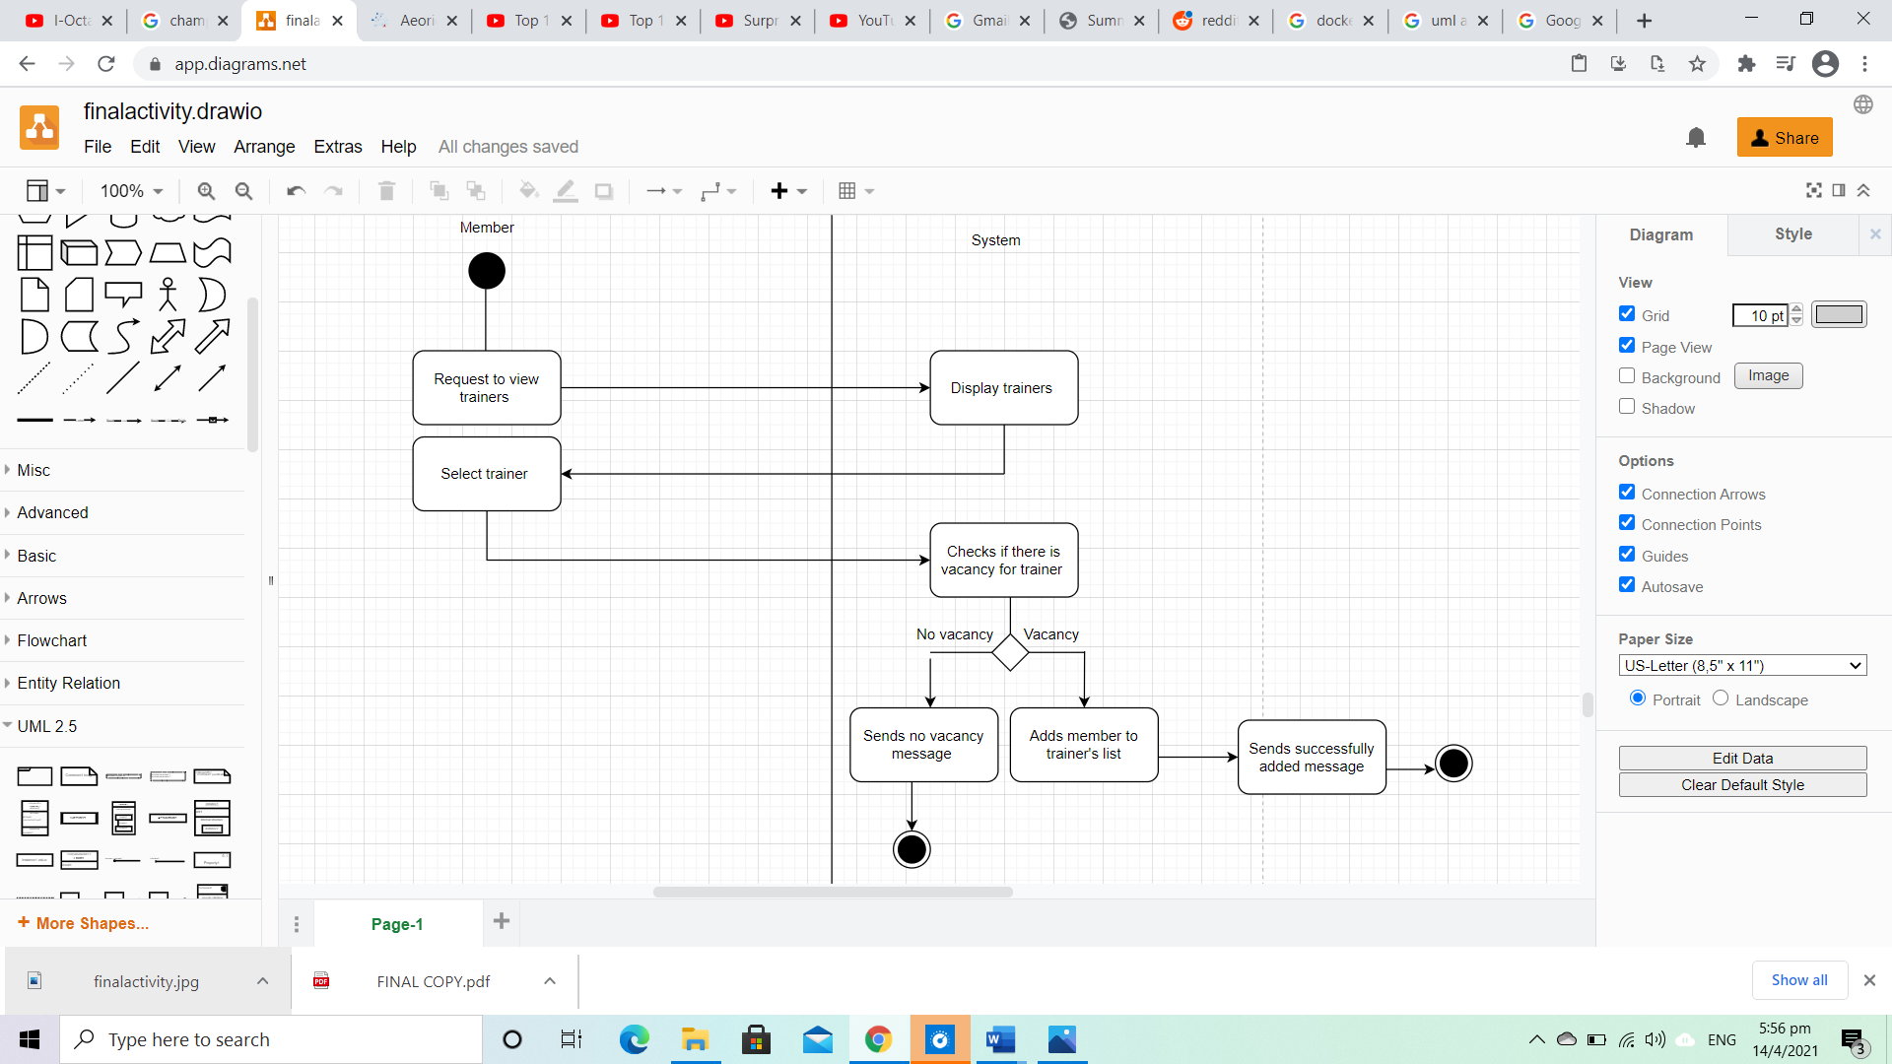

General Public Signing Up:

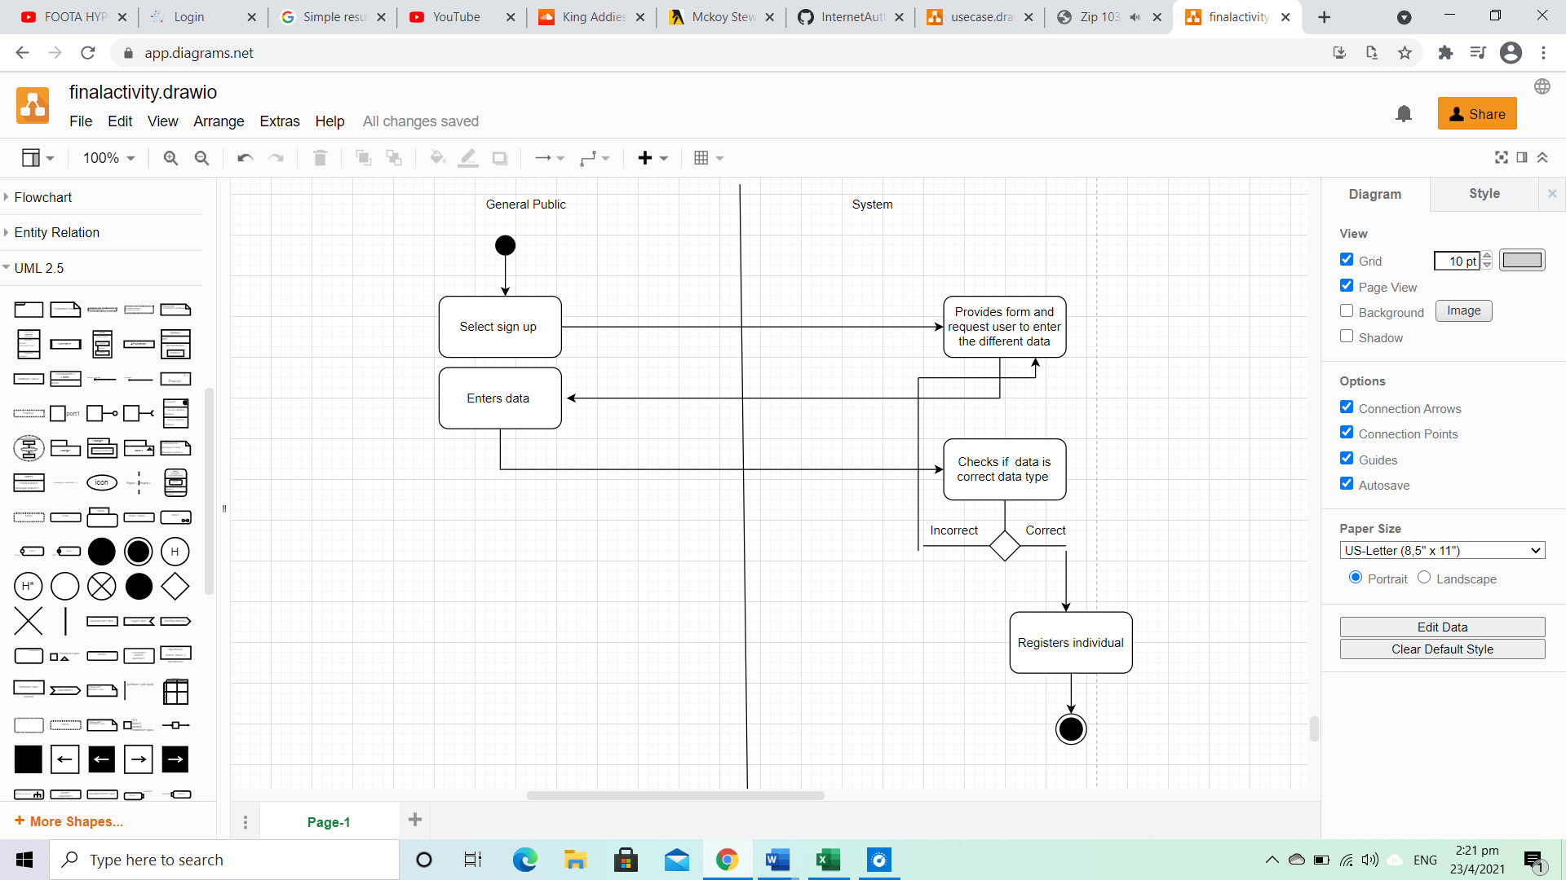

**Solution Innovation:**

This system would be innovative because even though some gyms in Jamaica namely Express Fitness may have a website that allows users to sign up it lacks the functionality to allow members to select trainers online and schedule visits all from the comfort of their homes.

**Conclusion:**

In conclusion this software solution may serve as a tool for perceptive members and returning members to easily apply for a membership or renew an expired one without the hassle of traveling in these times just to sign a piece of paper.